Full Stack Development with MERN

1.Introduction
Project Title
ShopEZ – MERN Stack Online Shopping Platform
Developer

Name | Role | Responsibilities
Akshara Cheedalla | Full Stack MERN Developer | Designed and developed the complete ShopEZ application using the MERN Stack. Developed the React.js frontend, implemented RESTful APIs using Node.js and Express.js, designed the MongoDB database, integrated JWT authentication, managed product, cart, and order modules, developed the admin dashboard, performed testing, debugging, deployment, and prepared the complete project documentation.

2. Project Overview

Purpose
ShopEZ is a Full Stack MERN-based Online Shopping Platform designed to provide customers with a secure, reliable, and user-friendly shopping experience. The platform enables users to browse products, search items, manage shopping carts, place orders, and track purchases through an intuitive web interface. Administrators can efficiently manage products, categories, users, banners, and orders through a dedicated dashboard.
Traditional online shopping platforms often suffer from poor user experience, complicated checkout procedures, fake reviews, payment security concerns, and inefficient order management. ShopEZ addresses these challenges by providing a modern, scalable, and secure e-commerce solution using React.js, Node.js, Express.js, and MongoDB.
Objectives
- Build a complete MERN Stack application.
- Provide secure user authentication using JWT.
- Allow users to browse and search products.
- Enable shopping cart management.
- Support secure checkout and order placement.
- Provide an admin dashboard for managing products, users, and orders.
- Design a scalable MVC-based backend architecture.

Features
Customer Features
- User Registration
- Secure Login
- JWT Authentication
- Product Listing
- Product Search
- Product Filtering
- Product Details
- Shopping Cart
- Checkout
- Order Confirmation
- Order Tracking
- Order History
- Profile Management

Administrator Features
- Admin Login
- Dashboard
- Product Management
- Category Management
- User Management
- Order Management
- Banner Management
- Sales Analytics

3. Architecture
Frontend Architecture
The frontend of ShopEZ is developed using React.js and follows a component-based architecture. Each feature of the application is implemented as reusable React components, enabling modularity, maintainability, and scalability.
Major frontend modules include:
- Home Page
- Login
- Registration
- Product Listing
- Product Details
- Search & Filter
- Shopping Cart
- Checkout
- Orders
- User Profile
- Admin Dashboard
React Router DOM is used for navigation between pages. Axios is used to communicate with backend APIs.

Backend Architecture
The backend is developed using Node.js and Express.js following the MVC (Model–View–Controller) architecture.
Controllers
- Auth Controller
- Product Controller
- Cart Controller
- Order Controller
- User Controller
- Admin Controller
Models
- User
- Product
- Cart
- Order
- Category
Routes
REST APIs handle communication between frontend and database.

Database Architecture
MongoDB is used as the NoSQL database.
Collections include:
- Users
- Products
- Categories
- Cart
- Orders
- Reviews
Relationships are maintained using MongoDB ObjectIds.
The backend communicates with MongoDB using Mongoose ODM.

4. Setup Instructions
Prerequisites
Install the following software before running the project.
- Node.js (v18 or above)
- npm
- MongoDB Community Server or MongoDB Atlas
- Git
- Visual Studio Code
Installation
Clone Repository
git clone https://github.com/username/Shopez.git
Install Frontend
cd client
npm install
Install Backend
cd server
npm install
Environment Variables
Create a .env file.
PORT=5000
MONGO_URI=your_mongodb_connection
JWT_SECRET=your_secret_key

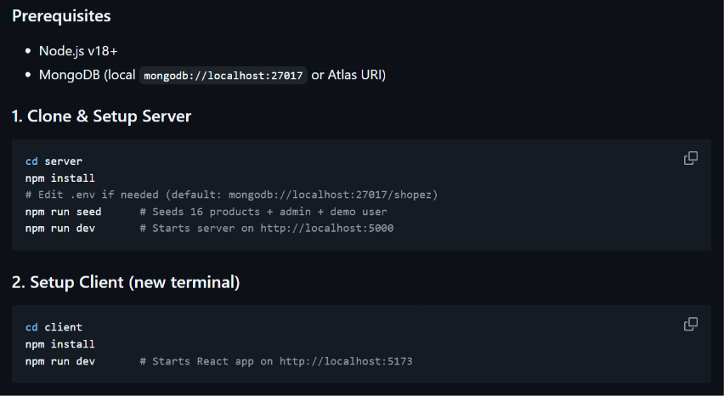

5. Folder Structure

Client
client
│
├── public
├── src
│ ├── components
│ ├── pages
│ ├── context
│ ├── services
│ ├── hooks
│ ├── assets
│ ├── App.jsx
│ └── main.jsx
Server
server
│
├── controllers
├── middleware
├── models
├── routes
├── config
├── utils
├── server.js
└── package.json
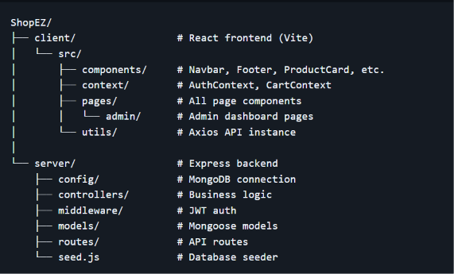

6. Running the Application
Backend
cd server
npm install
npm start
Backend runs at:
http://localhost:5000
Frontend
cd client
npm install
npm run dev
Frontend runs at:
http://localhost:5173

7. API Documentation
Authentication APIs

Method | Endpoint | Description
POST | /api/auth/register | Register User
POST | /api/auth/login | Login User
Product APIs
Method | Endpoint
GET | /api/products
GET | /api/products/
POST | /api/products
PUT | /api/products/
DELETE | /api/products/
Cart APIs
Method | Endpoint
GET | /api/cart
POST | /api/cart/add
PUT | /api/cart/update/
DELETE | /api/cart/remove/
Order APIs
Method | Endpoint
POST | /api/orders
GET | /api/orders
GET | /api/orders/
PUT | /api/orders/status/
User APIs
Method | Endpoint
GET | /api/users/profile
PUT | /api/users/profile

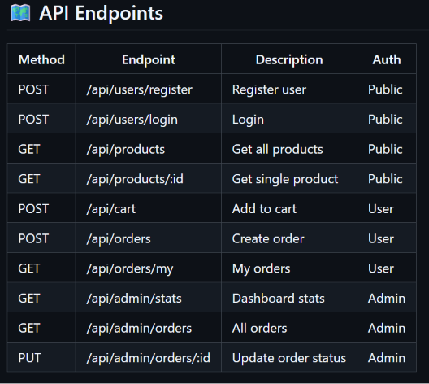

8. Authentication
ShopEZ uses JWT (JSON Web Token) authentication.
Authentication flow:
- User registers.
- Password is encrypted using bcrypt.
- User logs in.
- Server generates JWT Token.
- Token is stored on the client.
- Protected routes validate the JWT before granting access.
Role-based authorization separates Customer and Admin privileges.

9. User Interface
The application consists of responsive pages:
- Home Page
- Login Page
- Registration Page
- Products Page
- Product Details Page
- Shopping Cart
- Checkout
- Orders
- User Profile
- Admin Dashboard
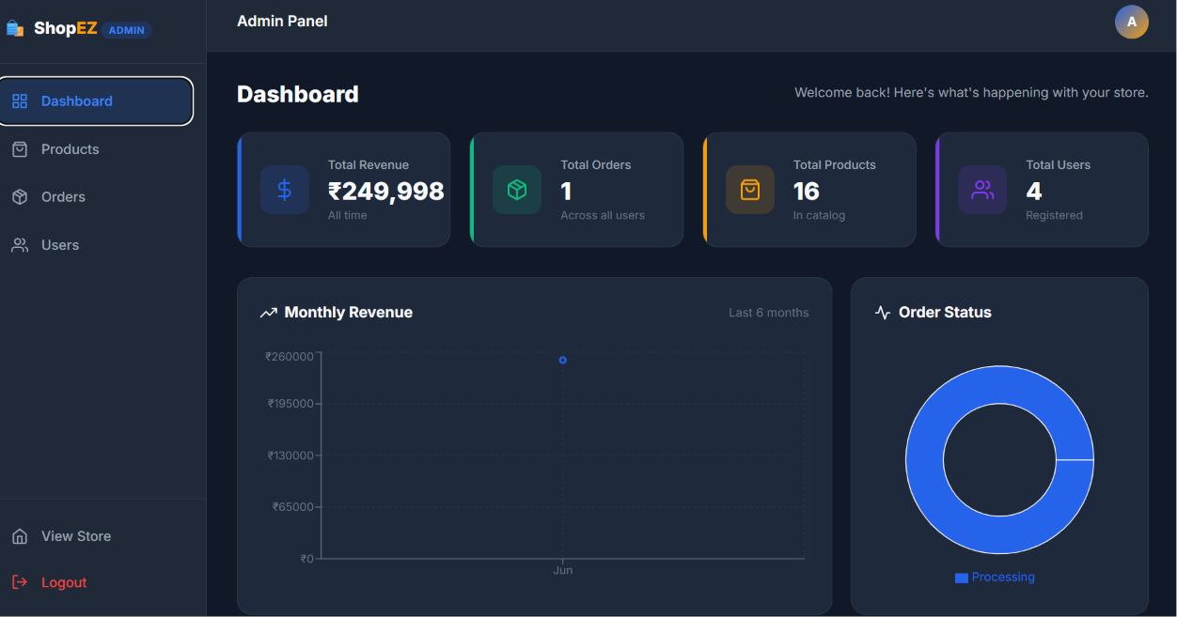
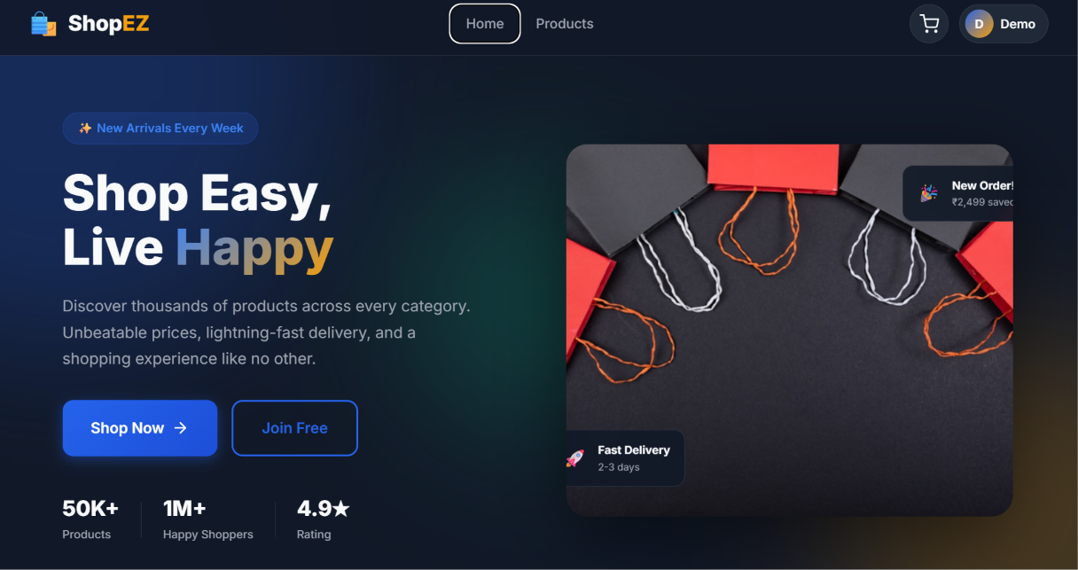

10. Testing
Testing included:
- Registration Testing
- Login Testing
- Product API Testing
- Cart Testing
- Checkout Testing
- Admin Testing
- JWT Authentication Testing
- MongoDB CRUD Testing
Tools Used:
- Postman
- Chrome Developer Tools
- MongoDB Compass

11. Screenshots or Demo
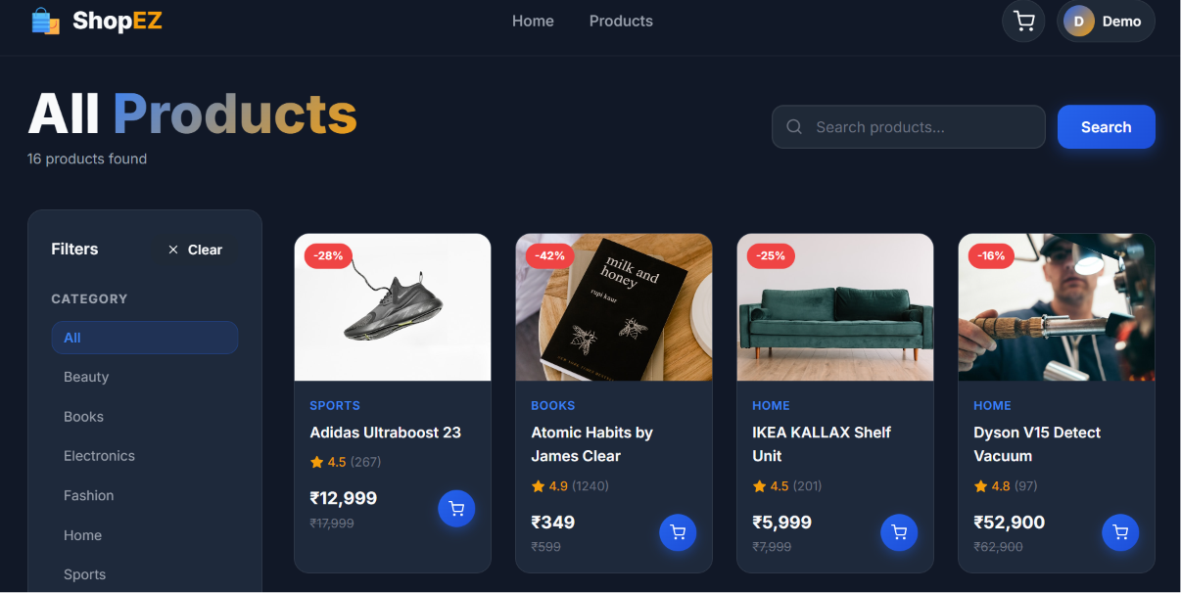

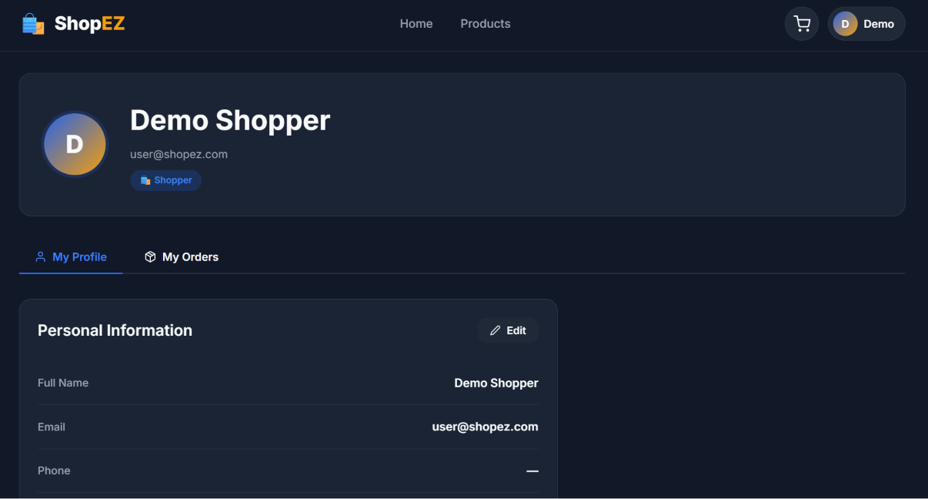

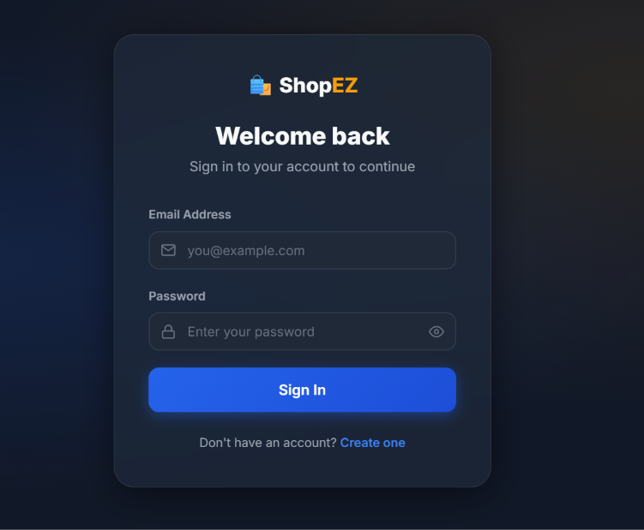

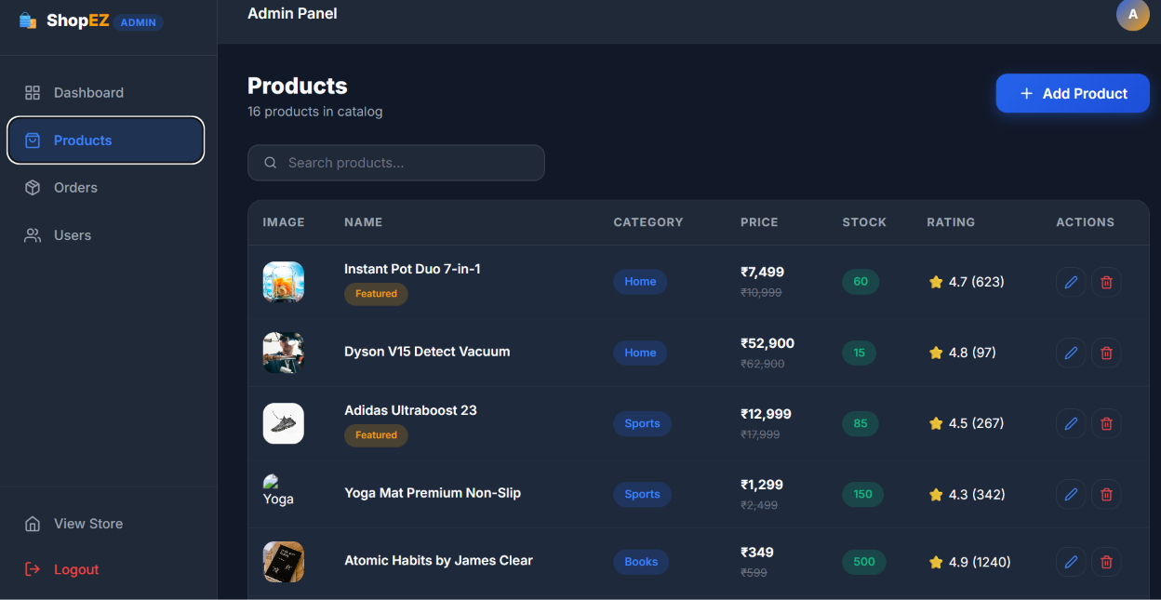

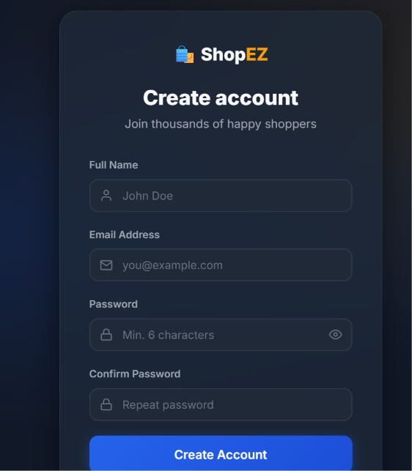

12. Known Issues
- Payment Gateway is currently in demo mode.
- Email verification is not implemented.
- Wishlist feature is not available.
- Product recommendations are basic.
- Limited analytics in the admin dashboard.

13. Future Enhancements
Future improvements include:
- AI-based Product Recommendation System
- Wishlist Module
- Product Review & Rating System
- Multiple Payment Gateways
- Coupon & Discount Management
- Inventory Management
- Mobile Application (React Native)
- Push Notifications
- Chat Support
- Live Order Tracking
- Cloud Deployment using AWS or Azure
- Docker & Kubernetes Deployment
- Elasticsearch for Faster Search
- Multi-language Support
- Dark Mode
- Analytics Dashboard with Charts
- Microservices Architecture for Scalability

